*Ayush Kumar*

*Section B | 202017B3622*

*COMPUTER Programming*

Assignment 2

Table of Contents

Section 1 (Strings) 2

1. A string consists of a sentence. Write a program to replace a part of the string with another part of the string 2

2. A paragraph consists of multiple lines. Write a program to count the number of articles in it. 2

Section 2 (Sorting and Searching) 2

5. Execute Selection sort algorithm manually to sort the following numbers 2

6. How do you search the elements 45, 50 and 18 with the Linear and Binary search methods? 2

Section 3 (Loops and conditions) 2

7. Write a program to display all the strong numbers between 100 to 999 2

8. Write a program to display all the cyclic numbers between 1 to 99. 2

Section 4 (Pointers and Structures) 3

11. Assume that there are ‘n’ employee records. Each employee record consists of employee name, employee number, department, designation and salary. Write a program to 3

a. Find the average salary of the employees 3

b. Display all the employees who are getting more than average salary 3

c. Find the total salary drawn by employees in each department 3

12. Assume that there is a linked list that begins with Begin and ends with End pointers. Write a program to 3

a. Find the biggest and smallest elements in the list 3

b. Find the number of elements which are prime 3

c. Find the number of elements which are divisible by 7 3

Section 5 (Arrays and Files) 3

13. Write a C program to define a structure called student with data members, name, register number, major, marks in core subject1, core subject2, allied, elective, total, average and grade. The data for name, register number, major, core subject1, core subject2, allied and elective are to be obtained from user. 3

a. Calculate total, average and grade for the students and update the data in the file. 3

b. Search for a student whose register number is obtained from the user as console input. 3

c. Find the first three highest averages and print those student’s details 3

14. Assume that there is an array consisting of ‘n’ elements. Write a program to store all the prime numbers of the list in a file called as “PRIME” and non-prime numbers in another file called as “NPRIME”. You have to define a function to check whether an element is a prime or not 3

# Section 1 (Strings)

## A string consists of a sentence. Write a program to replace a part of the string with another part of the string

Example:

Input: Give String: Mary goes to Delhi. She is doing the M.Tech at our college

Replaced String: has come from (issue with the output)

Position to replace: 5 to 11 (Start and end positions to replace)

Output: Mary comes from Delhi. She is doing the M.Tech at our college

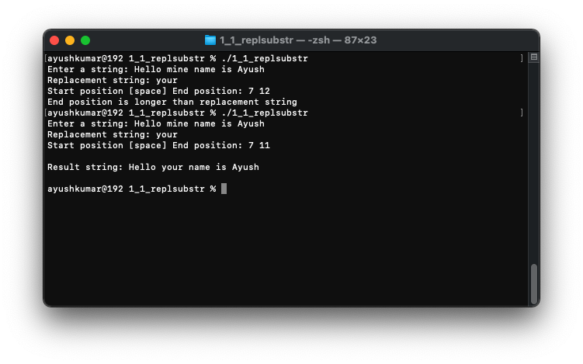

## A paragraph consists of multiple lines. Write a program to count the number of articles in it.

Input:

C was invented by Dennis Ritchie. It is **a** middle level language. It has lot of operators. **An** operator is **a** symbol for performing **an** operation. There are various predefined functions. Some of them are: printf(), pow(), Sin().

Output: 4

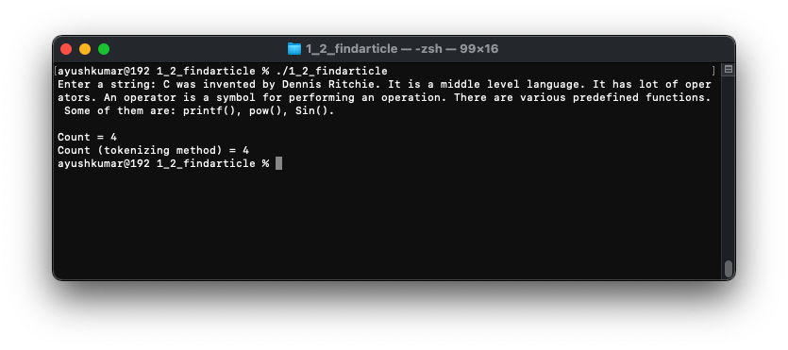

# Section 2 (Sorting and Searching)

## Execute Selection sort algorithm **manually** to sort the following numbers

55, 23, 45, 12, 67, 20, 34, 10, 54, 50, 19

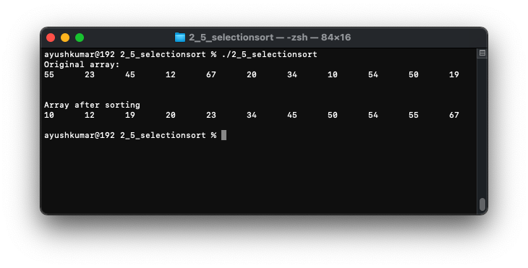

## How do you search the elements 45, 50 and 18 with the Linear and Binary search methods?

Assume that the following set of elements are given:

55, 23, 45, 12, 67, 20, 34, 10, 54, 50, 19

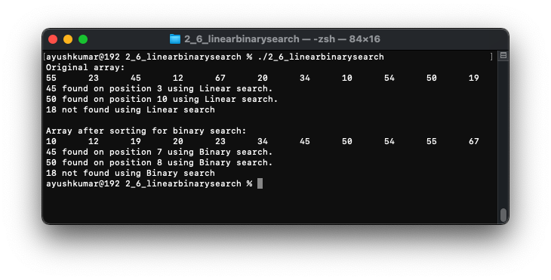

# Section 3 (Loops and conditions)

## Write a program to display all the strong numbers between 100 to 999

A strong number is a number in which the **sum of the factorial of the digits is equal to the number itself**. (Example: 145 = 1! + 4! + 5!)

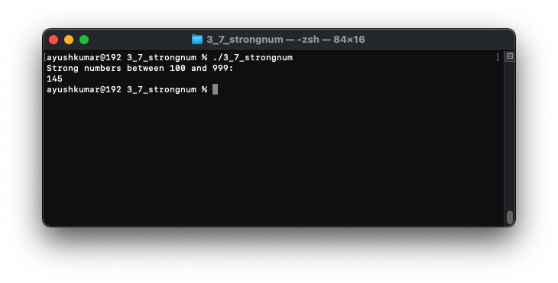

## Write a program to display all the cyclic numbers between 1 to 99.

A cyclic number is a number if its square ends with the number. Examples: 6 (62 = 36), 5 (52 = 25 ) ,76 (762 = 5776 )

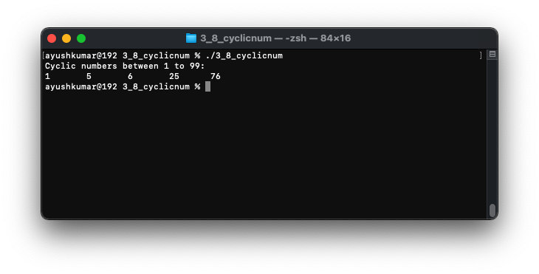

# Section 4 (Pointers and Structures)

## Assume that there are ‘n’ employee records. Each employee record consists of employee name, employee number, department, designation and salary. Write a program to

### Find the average salary of the employees

### Display all the employees who are getting more than average salary

### Find the total salary drawn by employees in each department

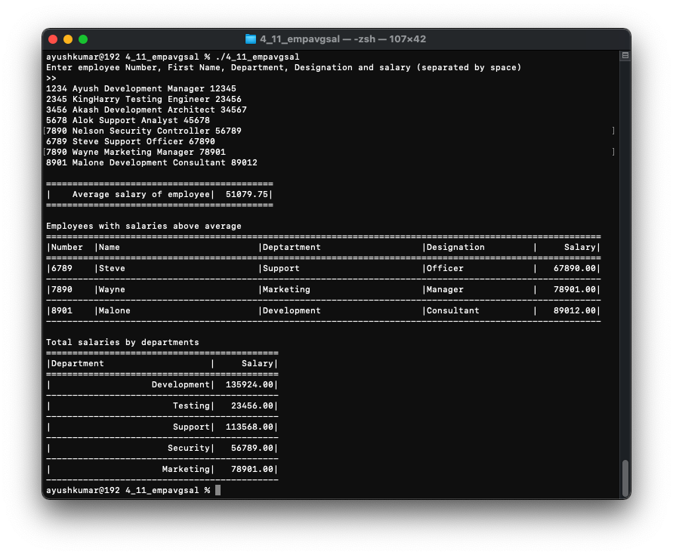

## Assume that there is a linked list that begins with Begin and ends with End pointers. Write a program to

### Find the biggest and smallest elements in the list

### Find the number of elements which are prime

### Find the number of elements which are divisible by 7

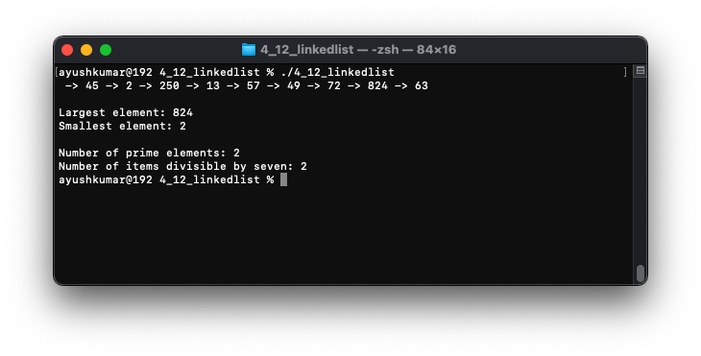

# Section 5 (Arrays and Files)

## Write a C program to define a structure called student with data members, name, register number, major, marks in core subject1, core subject2, allied, elective, total, average and grade. The data for name, register number, major, core subject1, core subject2, allied and elective are to be obtained from user.

### Calculate total, average and grade for the students and update the data in the file.

### Search for a student whose register number is obtained from the user as console input.

### Find the first three highest averages and print those student’s details

## Assume that there is an array consisting of ‘n’ elements. Write a program to store all the prime numbers of the list in a file called as “PRIME” and non-prime numbers in another file called as “NPRIME”. You have to define a function to check whether an element is a prime or not